10th ANNUAL

MEN’S FISHING RETREAT

WHEN
March 15th-18th 2023

WHERE
Loggy Bayou Coushatta LA

(See back for details)

MEN OF ALL AGES!!
SONS AND GRANDSONS ARE ENCOURAGED TO COME!

COST PER PERSON
$60

KIDS HALF PRICE PLUS LODGING IF
APPLICABLE
SEE THE BACK FOR DIRECTIONS AND ALL INFORMATION YOU NEED TO KNOW!

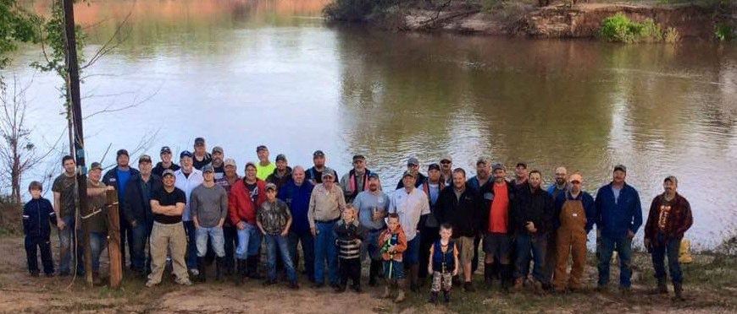

CONTACT CHANCE WAGGONER 903-646-8926
903-842-0092

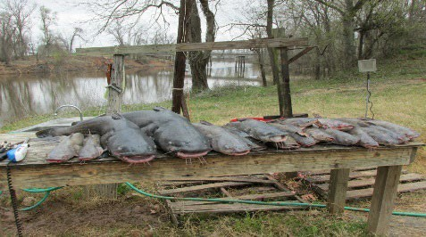
LOCATION OF RETREAT

The location of the retreat will be at Loggy Bayou address is 1702 Hwy 515 Coushatta LA 71019. Additional logging if needed can be attained at Red River South Marin, 318-747- 9545 Address is 250 Red River South Marina Rd, Bossier City, LA 71112. This location has cabins for rent and travel trailer hook ups as well as a Marina with gas and other amenities. If you have an RV there is a much closer site 5 miles from our loggy camp, Evelyn's RV Park, call 318-525-5092 for reservation $25.00 per night.

Directions to Loggy Bayou Fish camp:
Address - 1702 Hwy 515 Coushatta La 71019
Traveling East on I-20 to Shreveport, take Exit 20A “Hamilton Rd Diamond Jacks Blvd. Take a right on to Diamond Jacks Blvd. Then take a left on Arthur Ray Teague Pkwy, which is right in front of Diamond Jacks Casino, stay on Arthur Ray Teague Pkwy until it “T’s” onto Hwy 71 aka Barksdale Blvd which is about 8.4 miles and take a right. Travel south on Hwy 71 for 19 miles and take a right on Hwy 515. Travel approximately 3.5 miles and the camp will be on the right as soon as you cross Loggy Bayou. The gate entrance is immediately on the right past the Bridge. GPS Coordinates N32.192509* W-93.442768*

Private Camp INFO/Loggy
There are 3 Large Campers on site and 1 medium camper on site and an additional 5 campers will be on site as well. ($5 per night for tents) Bring Toiletry supplies and sleeping bags. We have a shower/bath house to get cleaned up in. Campers sleep 40-45 depending on how much togetherness your good with so get signed up, first come first served on the sign up sheet.
We usually eat breakfast before we run lines in the morning, then we come back and everyone eats a snack for lunch. Wednesday night you bring what you want to eat and you can cook it on the grill or you eat it cold. We will have BBQ Thursday night, and Fish & Crawfish Friday night. Be sure to bring your own snacks and drinks, breakfast and dinner will be included in the cost per person. We will send out devotions in the morning to everyone’s cell phone so please text Chance/Tater your name and number before you come so you can get put on the group text. We will have evening devotions daily.

Bring any games you want,
purchased online through Louisiana parks and wildlife.
Be sure and purchase a Louisiana fishing license before arrival. Fishing license can be

